PUNE INSTITUTE OF COMPUTER TECHNOLOGY, PUNE

Department of Computer Engineering

A.Y. 2020-21 SEM – I

Subject: DBMSL

Mini Project Report

Under the Guidance of:- Prof. Deepali Kadam.

Product Rating and Review System

By:-

Aditya Chavan - 31318

Aditya Sawant – 31302

1. **Introduction**

This section will give an overview of the Ratify web application. The basic functionality of the system as well its context will be explored in detail. It also describes different kinds of modules associated with the system and what functionality is available for each module. At last, the assumptions and dependencies for the system are presented.

1. **Abstract**

Product rating and review system is a web based application which aims to simplify the process of rating products and exchanging information related to a certain product so as to determine its value in the market. This document aims to capture the system requirements and features particularly related to putting up a product to be reviewed, writing or referring to a product review as well as determining best options in a specific category based on its rating.

1. **Scope**

Ratify is a product review and rating system developed with the intention of providing consumers with actual information about the products they would purchase. This information comes from the feedback of owners of the product as well as individuals dedicated to the review industry. This release of web application is currently limited to reviewing popularly used electronic appliances and the feedback is limited to only textual and numeric format. In future versions this limitations could be removed which may allow users to share their experiences using image and video format. Also experiences may not be limited to objects, it may be expanded to services such as restaurants, tourist destinations, educational institutions, etc. The aim of this system is to provide people with information they would need before they purchase the product. If there were manufacturing flaws within a product, users could avoid that product. Reviews have the ability to shape the market. Large multinational corporations use aggressive advertising with which smaller companies cannot directly compete. This system provides unbiased information straight from the product owners to the users.

1. **Product Perspective**

Ratify web app will attempt to reduce the dependency of users on sparse review articles and vague claims of manufacturers aimed at boosting sales for purchasing a product by providing them with reviews and experiences from product owners directly. Ratify has two basic components: the frontend web app and the backend as database linked together using python. The web app will be used to post a new product description and image to which owners can answer questions to and share their experience with. Each review can be individually edited or deleted by the user provided the review was written by him. Using database techniques top rated products are calculated and viewed separately on the home page. Apart from this, each product has an average rating calculated from all of its existing reviews and popularity chart to show variations in rating over time.

## Product Functions

* Allow users to create an account
* Allow users to edit their details
* Allow users to add a product to be reviewed
* Allow users to add their rating and review
* Allow users to modify or delete their existing reviews
* Allow users to view all reviews of a product
* Allow users to view all products sorted by category
* Allow users to view average rating of each product
* Allow users to view latest reviews posted by users
* Allow users to view highest rated products from each category
* Allow users to view popularity chart for each category

1. **Functional Requirements**
2. **Login page**

* The system should redirect user to home page only if correct credentials are entered.
* The system should prompt user to re-enter their credentials with an error message if authentication fails.
* The system should provide user option to stay signed in on the device.
* The system should also redirect new users to registration page.

1. **Registration page**

* The system should accept required information from user.
* The system should correctly enter all input into the database.
* The system should redirect user to home page after successful creation of account.

1. **Home Page**

* The system should display the most recently posted reviews and top picks from each category.
* On clicking the product name, the system should redirect the user to product page on which the review was added.
* On clicking the username, the system should redirect the user to user info page.
* The system must give user ability to navigate to other pages.
* The system must give user ability to logout from the account.

1. **Add product page**

* The system should allow the user to enter relevant information and add a product to be reviewed.
* On clicking text fields, system should accept input from user.
* On clicking “Choose File”, system should open file manager to accept .jpg or .png files as input.
* On clicking category field, system should display available categories of products for user to choose from.
* The system should not allow user to leave any field blank.
* The system must give user ability to navigate to other pages.

1. **Products page**

* The system should display all products details of specific category which include name, image and description of product.
* Clicking each product should redirect its review page.
* Each product should display its number of reviews and its average rating.

6.   **Reviews page**

* The system should display all the details of the product which include name, description, price, average rating and number of reviews.
* The system should display all the reviews of the product along with the rating.
* On clicking the username of the reviewer, the system should redirect users to the reviewer’s profile.
* The system should also accept user review as input and add it to the list of existing reviews.

7.   **Statistics page**

* The system should accept product category as input.
* The system should display charts based on popularity of each product from the selected category.

1. **Non Functional Requirements**
2. **Performance Requirements**

The system must be interactive, and the delays involved must be less. So, in every action response of the system, there are no immediate delays. In case of scrolling through the web app the data should be retrieved as quickly as possible for a smooth user experience. Also login and signup activity should keep loading times to minimal. Note that user’s internet speeds may affect loading times.

## Safety Requirements

The software is completely environmentally friendly and does not cause any safety violations. The web app will have a flexible font that can be zoomed so as to not strain the eyes of the user.

1. **Security Requirements**

The system has a proper and encrypted login authentication for users. This prevents hacker access to sensitive user information. Information transmission should be securely transmitted to database without any changes in information. Also reviews of other users should not be edited or deleted by any other user.

## Software Quality Attributes

* Adaptability

User reviews can be edited or deleted at any time after they have been posted.

* Availability

The system is up and running for all the time and server is not down for more than a few minutes to avoid inconvenience of the users.

* Correctness

The average rating generated by the application must be accurate and the reviews should exactly be the same as user has written.

* Flexibility

If need arises in the future, software can be modified to change the requirements.

* Maintainability

Software can be easily repaired if a fault occurs.

* Portability

Software will and would run smoothly according to the requirement.

* Reliability

No matter how many reviews are entered, system must give the correct results.

* Reusability

Current version can be used in the future versions with more functionality added.

* Testability

All the requirements are fulfilled, response time is low, and all functions are working perfectly.

1. **Data Modelling Features:**

**Entity Relationship Diagram:**

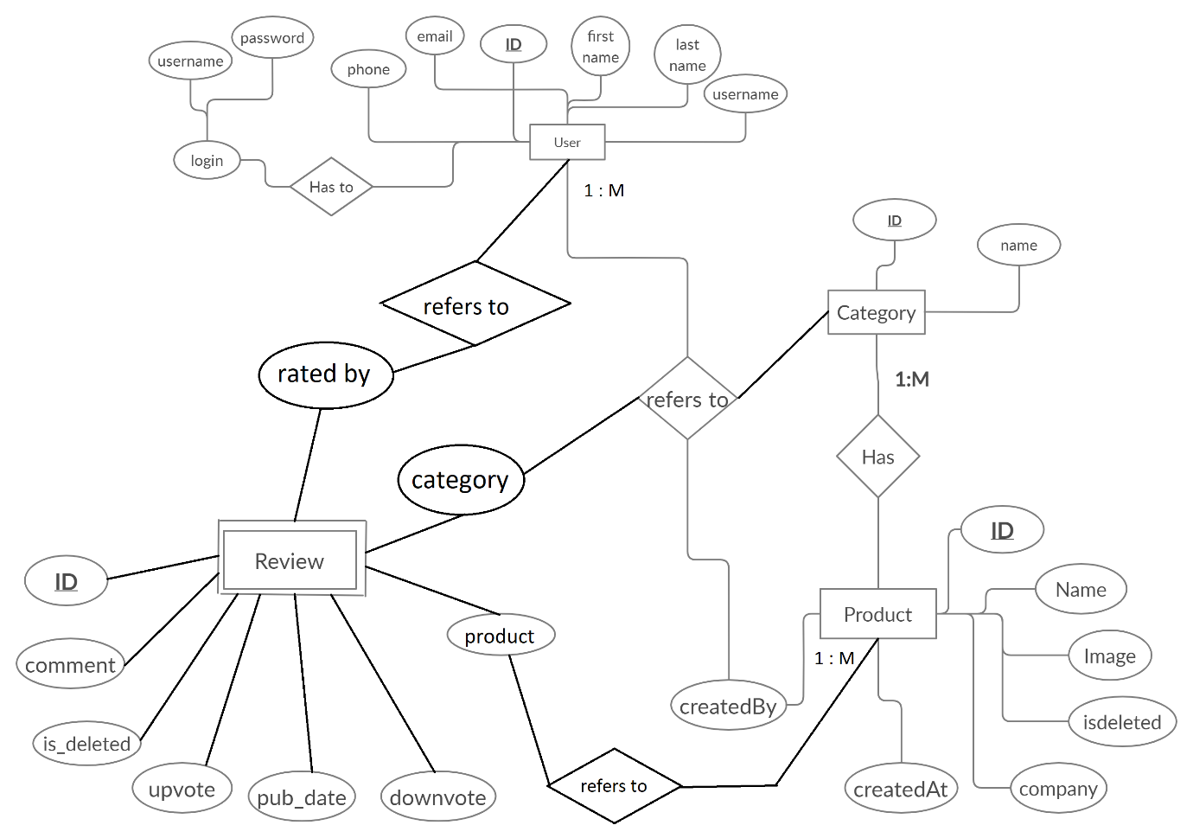

1. **Data Dictionary:**

* Review table

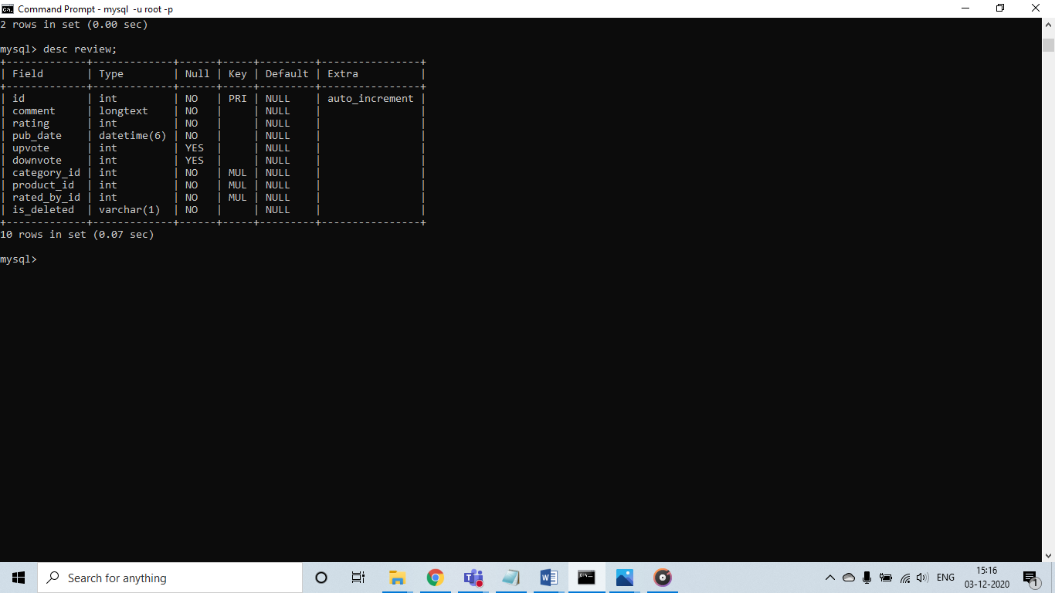

* Product table

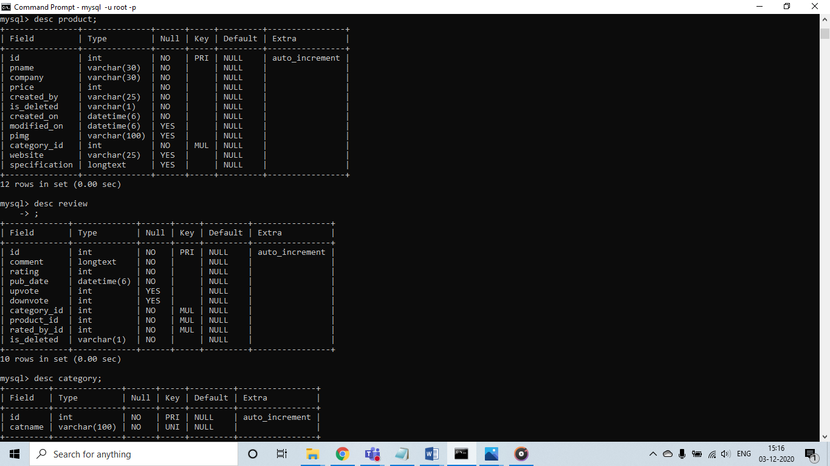

* App User table

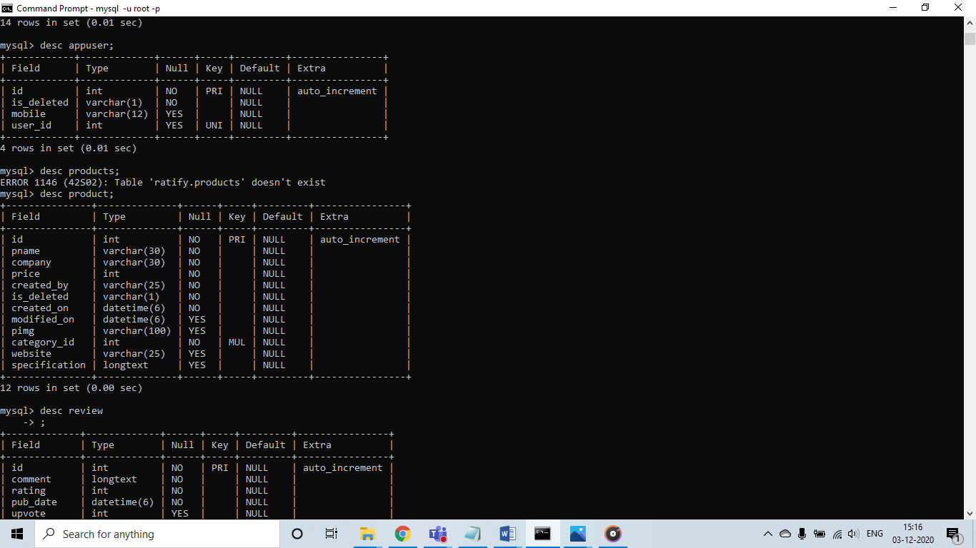

* Category table

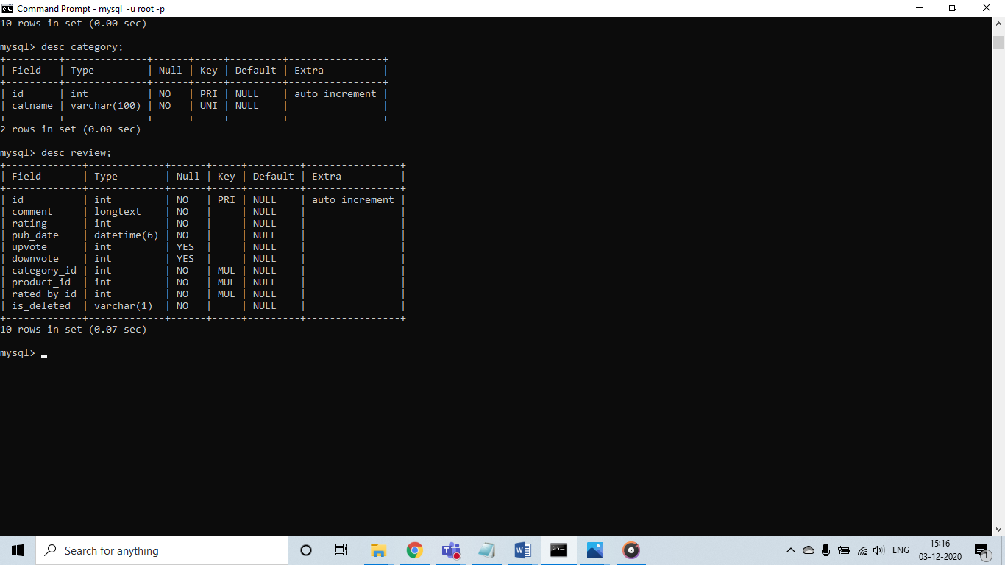

* Auth_user table:

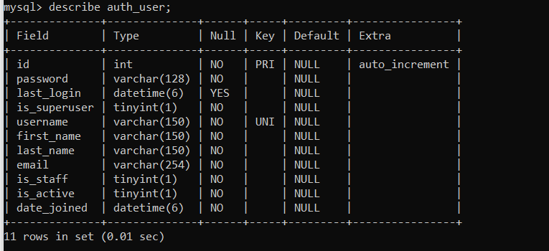

10. **Relational Database Design**

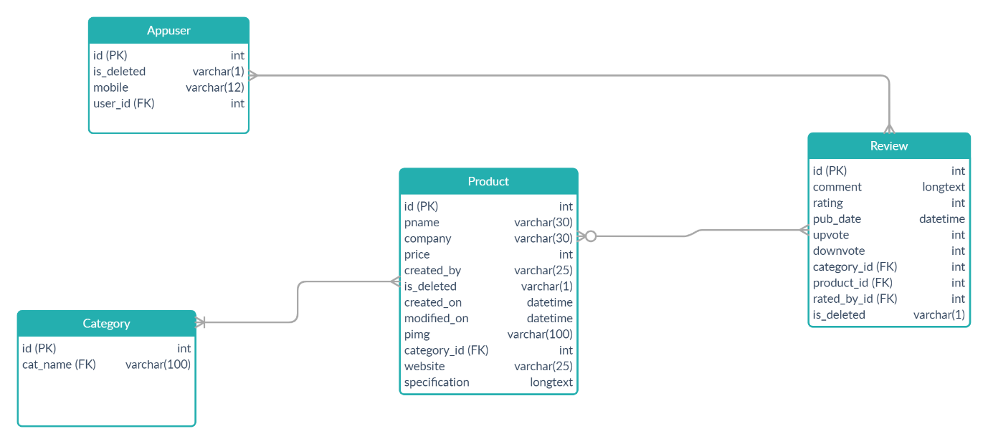

11. **GUI**

* 1. Login page

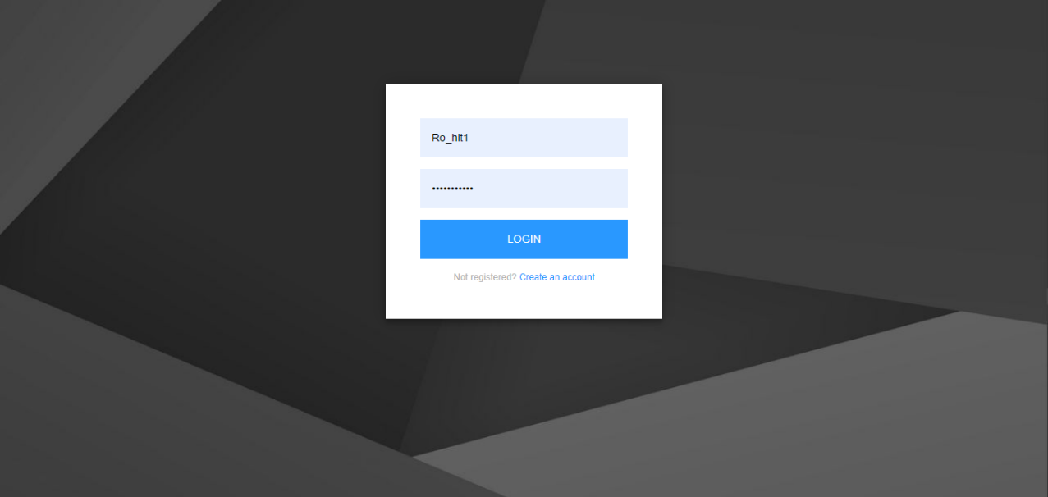

* 1. Registration page

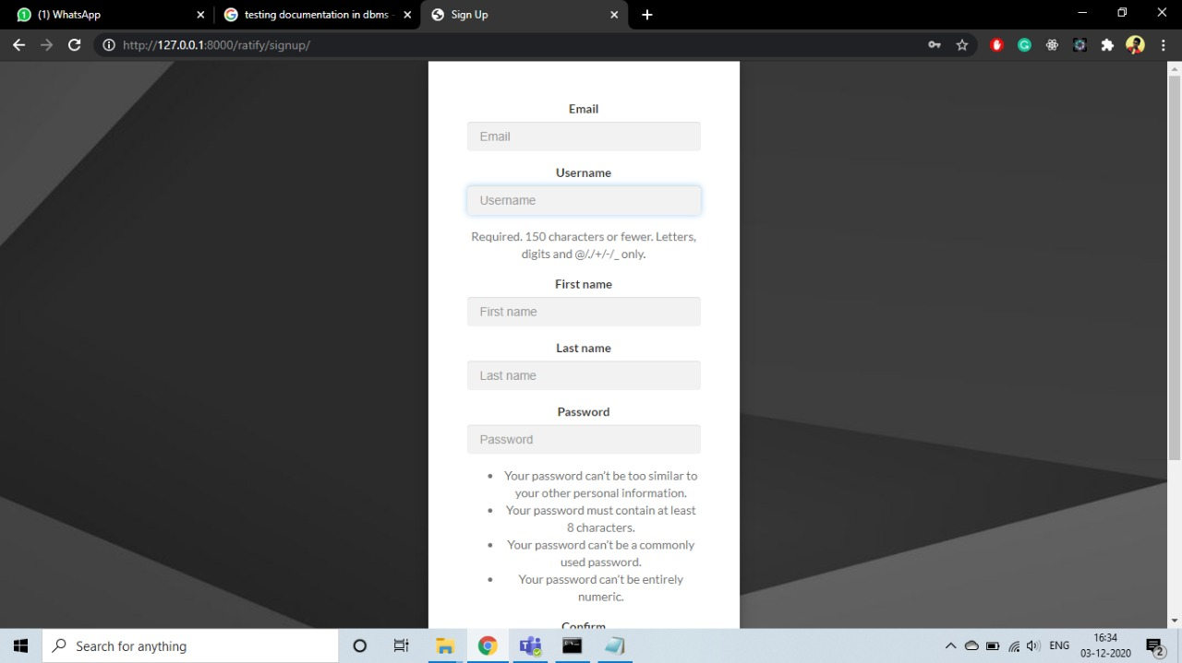

* 1. Home Page:

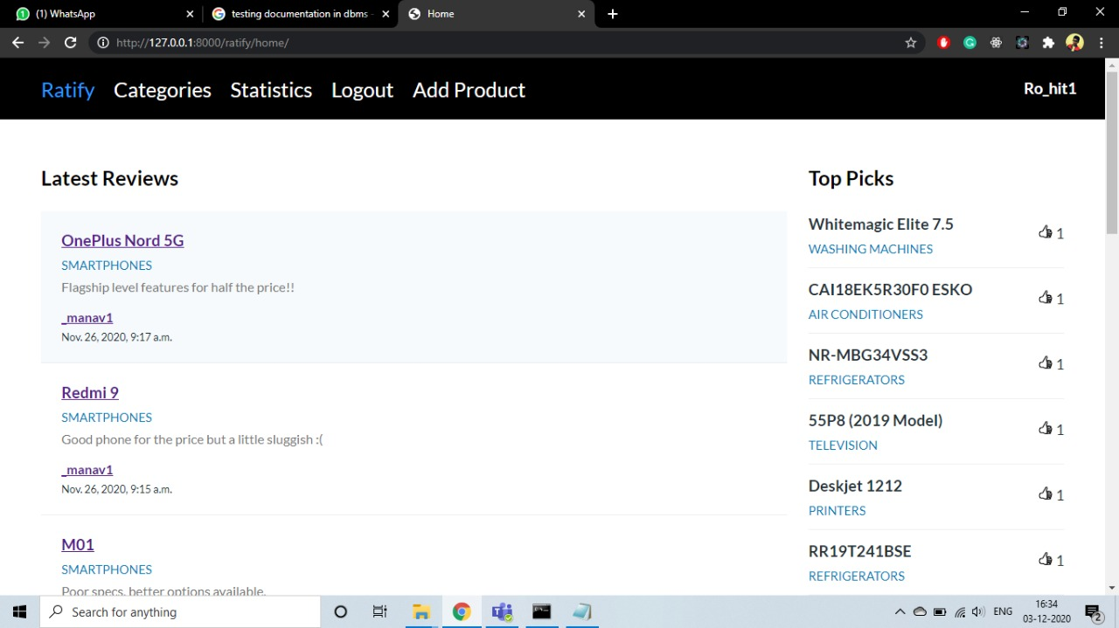

* 1. Categories

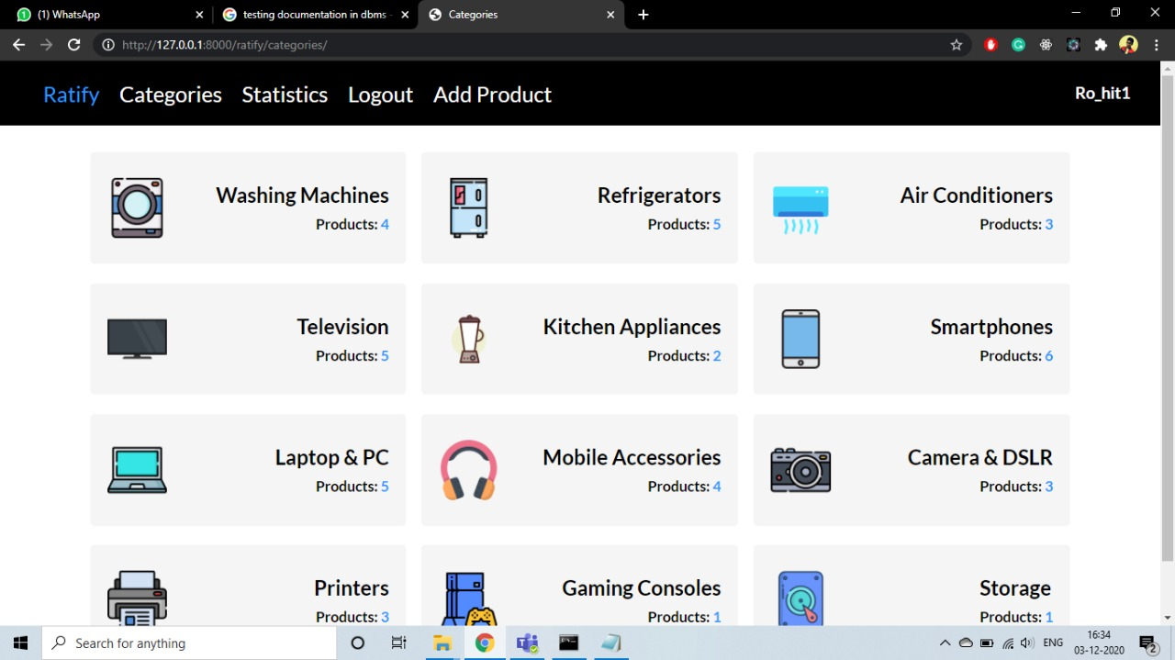

* 1. Statistics

* 1. Add new product:

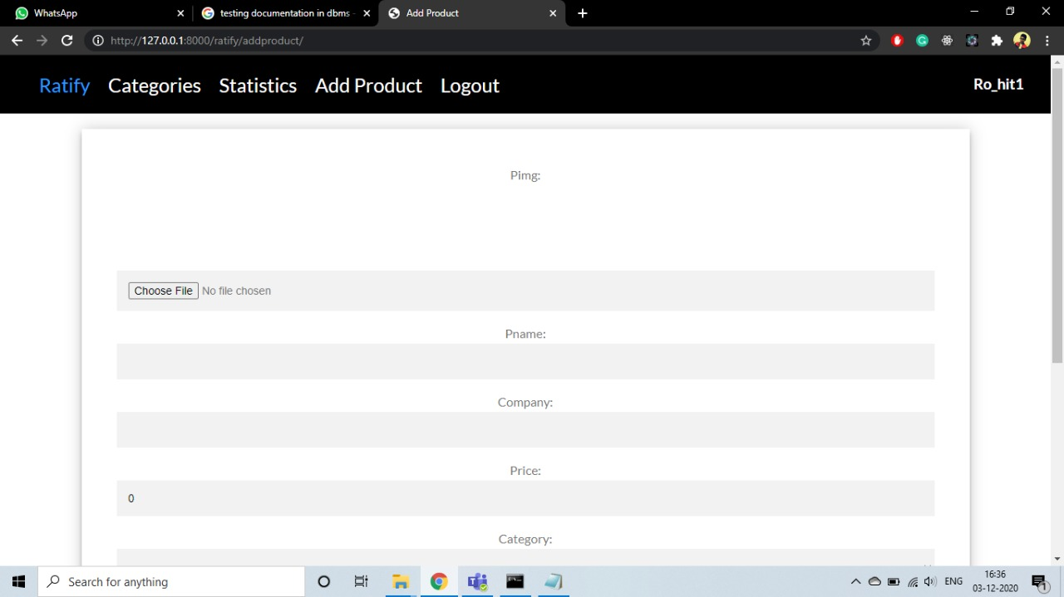

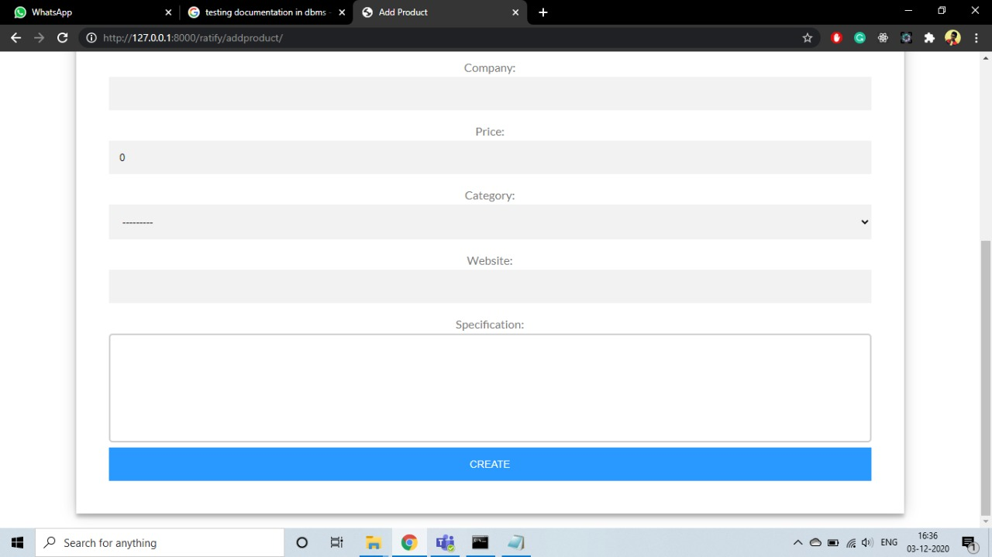

* 1. Products

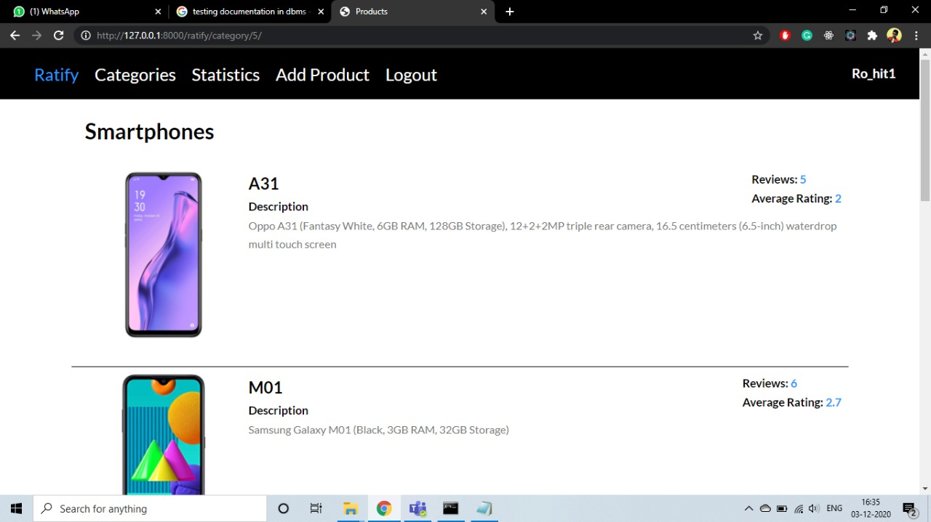

* 1. Reviews

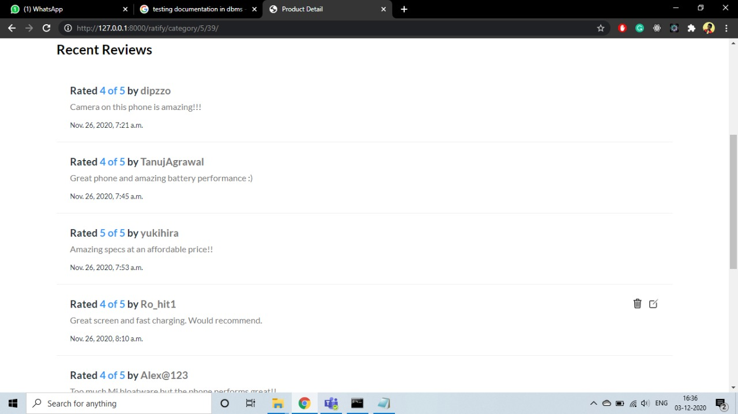



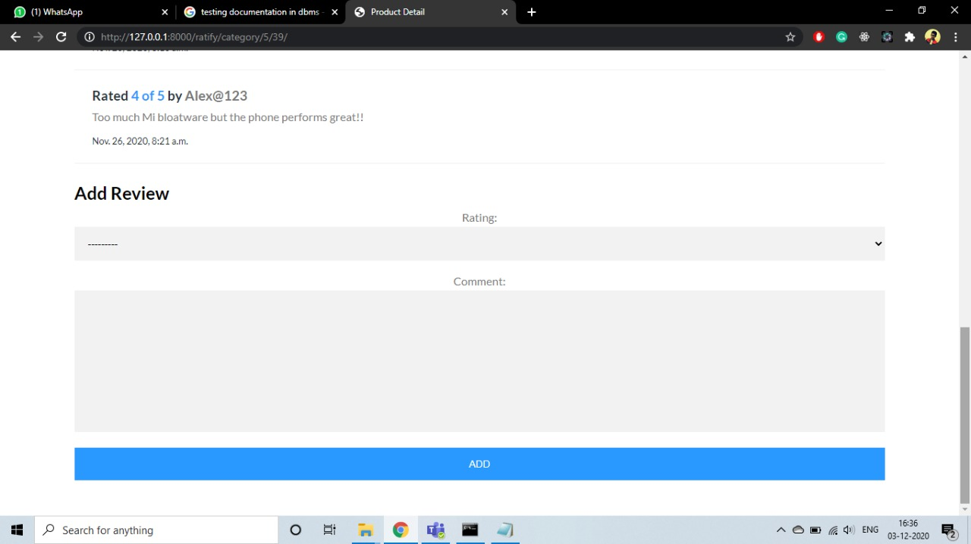

* 1. User Info

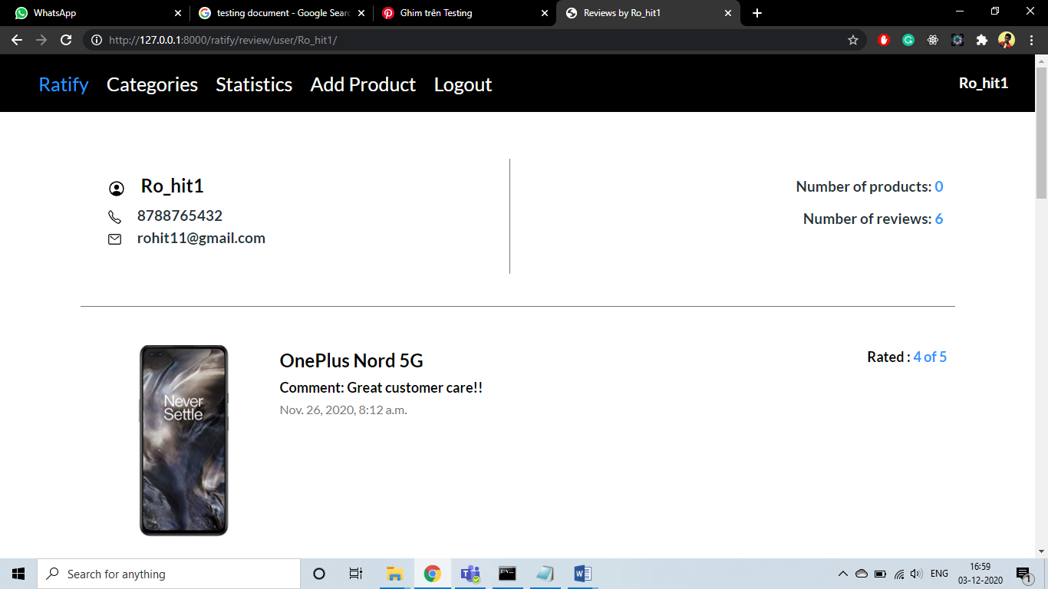

12. **Technology Stack**

1. Front End

* + HTML
  + CSS
  + Javascript

2. Back End

* + Python

3. Database

* + MySQL

4. External Libraries

* + Chart.js

13. **Source Code**

<https://github.com/Adi1222/Ratify>

14. **Conclusion**

Thus we have successfully designed, constructed, implemented and tested Ratify, a web based product review and rating system. We have implemented important database management concepts such as relational database, primary and foreign key constraints, developed a GUI for user to interact with using HTML and CSS and linked those using Python. We also have documented the design procedure and requirements of the project along with database model, database dictionary and relational database design.